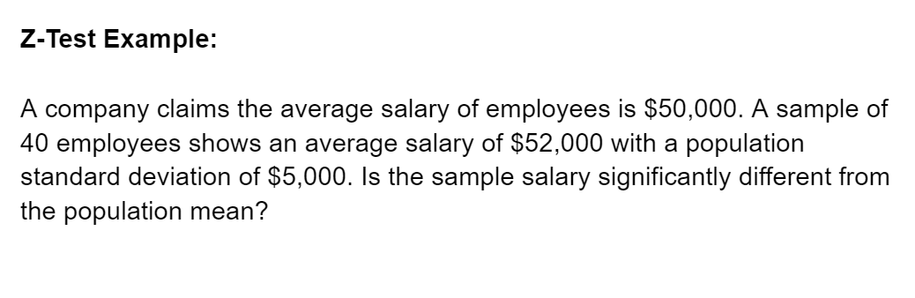

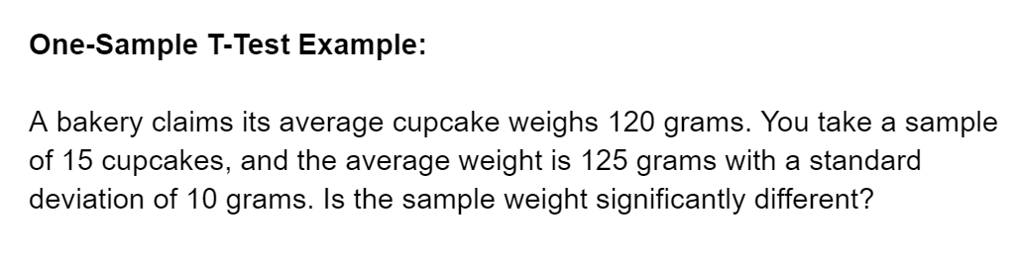

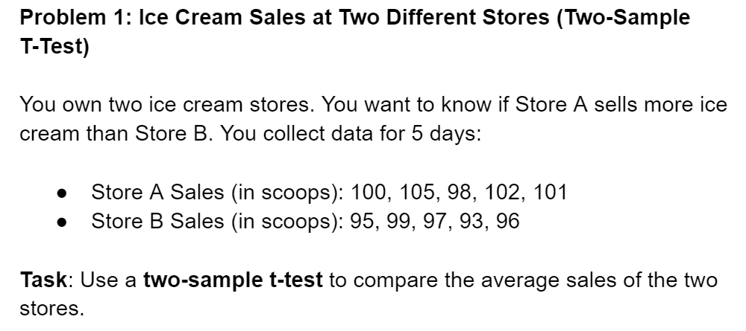

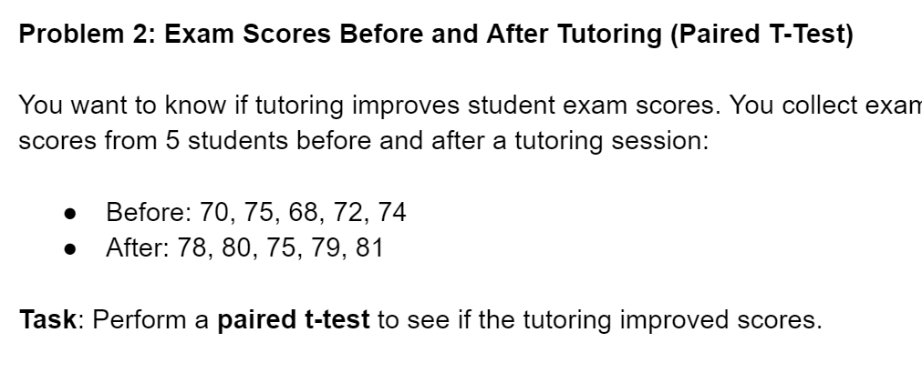

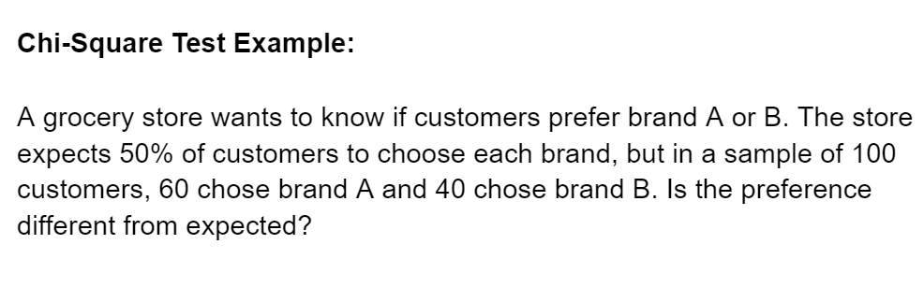

**MORE QUESTIONS :**

### **1. Z-Test Example**

A factory claims that the average weight of a product is 50 kg. You take a sample of 40 products and find the average weight is 52 kg, with a population standard deviation of 4 kg. Is the sample weight significantly different?

### **2. One-Sample T-Test Example**

A bakery claims its average cupcake weighs 120 grams. You take a sample of 15 cupcakes, and the average weight is 125 grams, with a sample standard deviation of 10 grams. Is the sample weight significantly different?

### **3. Two-Sample T-Test Example**

You want to compare the average test scores of two classes. Class A has an average score of 85 with a standard deviation of 8 (sample size = 30), and Class B has an average score of 80 with a standard deviation of 6 (sample size = 35). Is there a significant difference between the two classes?

### **4. Paired T-Test Example**

You want to test if a new teaching method improves student scores. You measure the scores of 10 students before and after using the method. The average score improvement is 5 points with a standard deviation of 3 points. Is the improvement significant?

### **5. Chi-Square Test Example**

You survey 50 people and ask if they prefer coffee or tea. The results are:

* 30 prefer coffee
* 20 prefer tea But you expect an equal preference (25 for each). Is the observed preference significantly different from what was expected?

**MORE PRACTICE QUESTIONS :**

### **1. Z-Test Example**

A shoe company claims the average size of their shoes is 9. You take a sample of 50 shoes and find the average size is 8.5, with a population standard deviation of 0.6. Is the sample significantly different from the claimed average?

### **2. One-Sample T-Test Example**

A company claims their employees work 40 hours a week on average. You take a sample of 20 employees and find the average is 38 hours, with a sample standard deviation of 3 hours. Is the average working time significantly different?

### **3. Two-Sample T-Test Example**

You want to see if two brands of cereal have different average sugar content. Brand A has an average of 10 grams of sugar with a standard deviation of 2 grams (sample size = 25), and Brand B has an average of 12 grams of sugar with a standard deviation of 3 grams (sample size = 30). Is there a significant difference in sugar content?

### **4. Paired T-Test Example**

You want to test if a new workout plan improves fitness scores. You record the fitness scores of 8 people before and after the workout plan. The average improvement in their scores is 7 points, with a standard deviation of 2 points. Is the improvement significant?

### **5. Chi-Square Test Example**

You conduct a survey to see if there is a preference between three types of pizza toppings (cheese, pepperoni, and veggie) among 60 people. The results are:

* 25 prefer cheese
* 20 prefer pepperoni
* 15 prefer veggie You expect equal preferences (20 for each). Is the observed preference significantly different?

Observed (O): Cheese = 25, Pepperoni = 20, Veggie = 15  
Expected (E): Cheese = 20, Pepperoni = 20, Veggie = 20